WEEK 7
Week Ending: 17-10-2025 |  | DAY: |  | Subject: COMPUTING
Duration: 50mins |  |  |  | Strand: Productivity Software
Class: B7 |  | Class Size: |  | Sub Strand: Introduction to Word Processing
Content Standard:  B7.2.1.1 Demonstrate how to use Microsoft Word (Editing) |  |  | Indicator:  B7.2.1.1.5 Demonstrate how to use text-decoration, change text case, text size and colour |  |  |  | Lesson:  1 of 1
Performance Indicator:  Learners can;  - Access and use the Font group in the Home tab of Microsoft Word.  - Change the font size and color of text.  - Apply font decorations such as bold, italics, and underline. |  |  |  |  | Core Competencies:  Communication and Collaboration, Critical Thinking and Problem solving
References: Computing Curriculum Pg.
Keywords: Font, Sentence Case, Font Size, ,Font Color Font Decoration
Phase/Duration | Learners Activities |  |  |  |  | Resources
PHASE 1: STARTER | Begin by discussing the importance of text formatting in documents.  Ask learners to think about why different text styles might be used in different types of documents (e.g., reports, flyers, invitations).  Show a brief example of a plain text document and a well-formatted document. Ask learners which one looks better and why.
PHASE 2: NEW LEARNING | Introduce the Font group under the Home tab in Microsoft Word.  Explain that this group of tools allows users to change the appearance of text, making it more readable and visually appealing.  Discuss how formatting can enhance communication by making key points stand out and improving the overall presentation of information.  Demonstrate how to change the size of text using the drop-down menu in the Font group.  Show how to change the color of text by selecting from the color palette.  Explain how to apply bold, italics, and underline to text.  Demonstrate how to use the sentence case tool to capitalize text, switch between uppercase and lowercase, and other capitalization options.  Use a computer to apply these formatting options to a sample document.  Show how to select text and then apply different formatting options using the Font group.  Provide learners with a plain text document that requires formatting.  Tasks:  - Change the font size of the title.  - Apply a different font color to the headings.  - Use bold and italics for emphasis in certain sections.  - Adjust the sentence case of the entire document to title case.  For learners who need additional help, provide a simple guide with screenshots of the Font group tools. Offer one-on-one assistance if needed.  Assessment  - How do you change the font size of text in Microsoft Word?  - What steps do you follow to change the color of text?  - Describe how to apply bold, italics, and underline to a selected text. |  |  |  |  | Computers with Microsoft Word installed  Sample document for practice
PHASE 3: REFLECTION | - What is the sentence case tool used for?  - How can formatting text improve the appearance of a document?  Use peer discussion and effective questioning to find out from learners what they have learnt during the lesson.  Take feedback from learners and summarize the lesson.

Week Ending: 17-10-2025 |  | DAY: |  | Subject: COMPUTING
Duration: 50mins |  |  |  | Strand: Productivity Software
Class: B7 |  | Class Size: |  | Sub Strand: Introduction to Word Processing
Content Standard:  B7.2.1.1 Demonstrate how to use Microsoft Word (Editing) |  |  | Indicator:  B7.2.1.1.6 Explore the use of the Paragraph group, using the align left, centre, align rightand justified in MS-Word under the Home tab. |  |  |  | Lesson:  1 of 1
Performance Indicator:  Learners can;  - Access and use the Paragraph group in the Home tab of Microsoft Word.  - Apply different text alignment options: Align Left, Center, Align Right, and Justified. |  |  |  |  | Core Competencies:  Communication and Collaboration, Critical Thinking and Problem solving
References: Computing Curriculum Pg.
Keywords: Align Left, Center, Align Right, Justified, Paragraph Group
Phase/Duration | Learners Activities |  |  |  |  | Resources
PHASE 1: STARTER | Begin by discussing the concept of text alignment and how different alignments can affect the appearance of a document.  Ask learners if they have noticed different alignments in books, websites, or other documents.  Show examples of text with different alignments. Ask learners which alignment they think looks best for certain types of documents (e.g., a letter, a poster, a report).
PHASE 2: NEW LEARNING | Introduce the Paragraph group under the Home tab in Microsoft Word.  Explain that this group of tools controls the alignment and spacing of text, which is important for creating well-organized and visually appealing documents.  Demonstrate how to align text to the left, which is the standard alignment for most documents.  Discuss how choosing the right alignment can enhance readability and convey a professional look in various types of documents.  Show how to center text, commonly used for titles and headings.  Explain how to align text to the right, often used for dates and other specific elements in a document.  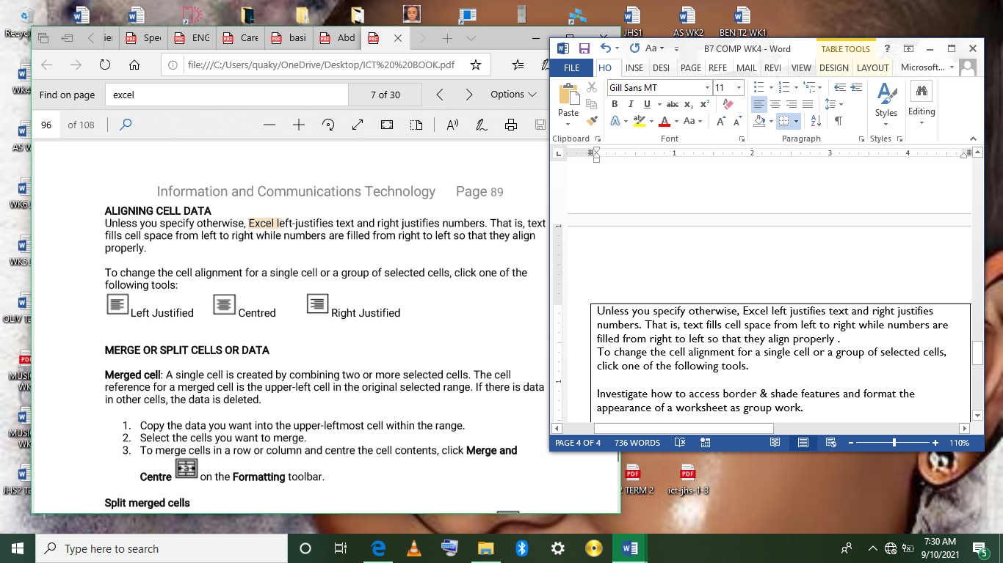  Left  Center  Right  Justify  Demonstrate the justified alignment, which aligns text evenly along both the left and right margins, commonly used in books and newspapers.  Use a sample document to show how each alignment option affects the appearance of the text.  Highlight how to access and apply these options from the Paragraph group.  Provide learners with a sample document containing unaligned text.  Tasks:  - Align the main body of the text to the left.  - Center the title of the document.  - Align the date on the top right corner of the page.  - Justify the main paragraph to create a neat block of text.  For learners who need additional help, provide a step-by-step guide with screenshots of the Paragraph group tools. Offer one-on-one assistance if needed.  Assessment  - How do you align text to the left in Microsoft Word?  - What is the purpose of the Center alignment, and when might you use it?  - Describe how to align text to the right. |  |  |  |  | Computers with Microsoft Word installed  Sample document for practice
PHASE 3: REFLECTION | - What does the Justified alignment do to text, and where is it commonly used?  - Which alignment option would you use for the body of an essay, and why?  Use peer discussion and effective questioning to find out from learners what they have learnt during the lesson.  Take feedback from learners and summarize the lesson.

Week Ending: 17-10-2025 |  | DAY: |  | Subject: COMPUTING
Duration: 50mins |  |  |  | Strand: Productivity Software
Class: B7 |  | Class Size: |  | Sub Strand: Introduction to Word Processing
Content Standard:  B7.2.1.1 Demonstrate how to use Microsoft Word (Editing) |  |  | Indicator:  B7.2.1.1.6 Explore the use of Bullets, Decrease and Increase Indentation under the Home tab |  |  |  | Lesson:  1 of 1
Performance Indicator:  Learners can;  - Apply bullets to a list in Microsoft Word.  - Increase and decrease indentation of text.  - Use the Border button to add borders to text. |  |  |  |  | Core Competencies:  Communication and Collaboration, Critical Thinking and Problem solving
References: Computing Curriculum Pg.
Keywords: Bullets, Indentation, Border, Line Spacing, Dialog Box Launcher
Phase/Duration | Learners Activities |  |  |  |  | Resources
PHASE 1: STARTER | Begin by asking learners if they have ever created lists, added borders, or adjusted spacing in a document.  Discuss the importance of these formatting tools in organizing and presenting information clearly.  Show examples of documents with and without bullets, indentation, borders, and line spacing adjustments.  Ask learners which documents are easier to read and why.
PHASE 2: NEW LEARNING | Introduce the tools under the Home tab in Microsoft Word that will be covered in the lesson: Bullets, Indentation, Borders, and Line Spacing.  Explain how these tools help in structuring documents, making them more visually appealing and easier to read.  Demonstrate how to create bulleted lists using the Bullets button in the Paragraph group. Show how to choose different bullet styles.  Show how to move text to the right using the Increase Indent button.  Demonstrate how to move text back to the left using the Decrease Indent button.  Explain how to add borders around text using the Border button in the Paragraph group. Show different border styles and where they can be applied.  Demonstrate how to adjust the spacing between lines of text using the Line Spacing button.  Show how to access more advanced line spacing options through the dialog box launcher in the Paragraph group.  Use a sample document to show how each tool affects the appearance and structure of the text. Highlight how to select and apply these formatting options.  Provide learners with a sample document that requires formatting.  Tasks:  - Add bullets to a list of items.  - Increase the indentation of a paragraph.  - Add a border around a heading.  - Adjust the line spacing of the main text.  For learners who need additional help, provide a step-by-step guide with screenshots of the tools. Offer one-on-one assistance if needed.  Assessment  - How do you add bullets to a list in Microsoft Word?  - What is the difference between increasing and decreasing indentation?  - Describe how to add a border to a paragraph. |  |  |  |  | Computers with Microsoft Word installed  Sample document for practice
PHASE 3: REFLECTION | - How do you adjust line spacing using the Line Spacing button?  - What advanced options can you find in the Line Spacing dialog box?  Use peer discussion and effective questioning to find out from learners what they have learnt during the lesson.  Take feedback from learners and summarize the lesson.

